New construction of the Hornbahn 2000

On the occasion of the 10th anniversary of Ski Juwel Alpbachtal Wildschönau, the starting signal is given by the Alpbacher Bergbahn for the construction of a new chairlift in Alpbach.

Alpbach - After 23 years, 16,567 operating hours and 7,129,813 people transported, the Hornlift 2000 has reached the end of its service life. Originally, the project was to start in 2020.
However, the corona-related break was used for careful planning and preparation of the investment. Now, after the successful construction negotiation on 17 May 2022, Alpbacher Bergbahn is presenting the plans for the new construction of the Hornlift 2000 with an investment volume of 10.5 million euros.

With the new construction, Ski Juwel Alpbachtal Wildschönau is taking another step towards modernity and comfort. Instead of the Hornlift 2000, a new detachable 6-seater chairlift with weather protection bonnet and seat heating is being built, which will take skiers to the highest point in the ski area in 3.45 minutes. As the transport capacity will be greatly improved by the new lift, measures have already been taken in summer 2021 to make the area around the Hornbahn 2000 accessible to skiers of all levels. Since the start of the 2021/22 winter season, there has been a new blue run in the area of the new chairlift.

The new top station promises to be an absolute highlight. Named "Top of Alpbachtal", this is to have an observation tower with new premises as well as an observation platform with a unique panoramic view. Snøhetta, an internationally renowned architectural firm with an office in Innsbruck, is responsible for the architecture. "Details are being planned and will be announced at a later date," says Reinhard Wieser, managing director of Alpbacher Bergbahn. With this project, he says, great importance is attached to sustainable and efficient implementation.

The new chairlift is a replacement investment. "With this, the Alpbacher Bergbahn in the Ski Juwel Alpbachtal Wildschönau is not investing in expansion, but in the quality of the offer with the aim of providing guests with a special mountain experience," Wieser emphasises. The new construction of the Hornbahn 2000 is an important step towards modernisation and sustainability.

Factbox „Hornbahn 2000“ www.skijuwel.com

FACTS & FIGURES of the new Hornbahn 2000
- Type of lift: 6-seater chairlift with weather protection bonnet & heated seats
- Speed: 5 m/s
- Altitude of the valley station: 1,638 m
- Altitude of the top station: 2,030 m
- Difference in altitude: 391.00 m
- Length: 1123,11 m
- Length of the trip: 3 min 45 sec
- Number of pillars: 11
- Number of chairs: 61
- Capacity: 2600 persons per hour
- Investment: approx. € 10.5 million
- Location: Alpbach
- Manufacturer: Leitner GmbH, Telfs
- Architect / Planning: Snøhetta, Innsbruck
- Start of construction: June 2022
- Completion: Start of winter season 2022/23
Contact:
Stefan Leitner 2.288 Signs
Alpbacher Bergbahn GmbH & Co. KG
Phone: +43 (0) 5336 5233 609
Mobile: +43 (0) 664 8865 3249 presse@skijuwel.com
stefan.leitner@alpbacher-bergbahnen.at www.skijuwel.com/presse

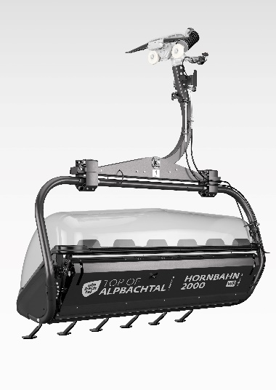
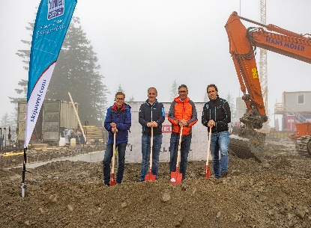
Chairdesign of the new “Hornbahn 2000” on Wiedersberger Horn
© Alpbacher Bergbahn

Thomas Lederer - Supervisory Board Chairman of Alpbacher Bergbahn, Frank Kostner - Head of Alpbachtal Tourism, Franz Maier - Sparkasse Kufstein & Reinhard Wieser - CEO of Alpbacher Bergbahn
© Alpbacher Bergbahn / Shoot&Style

